**Project Design Phase-II**

**Technology Stack (Architecture & Stack)**

|  |  |
| --- | --- |
| Date | 31 January 3035 |
| Team ID | SWTID1743353335 |
| Project Name | Book a doctor using MERN |
| Maximum Marks | 4 Marks |

**Technical Architecture:**

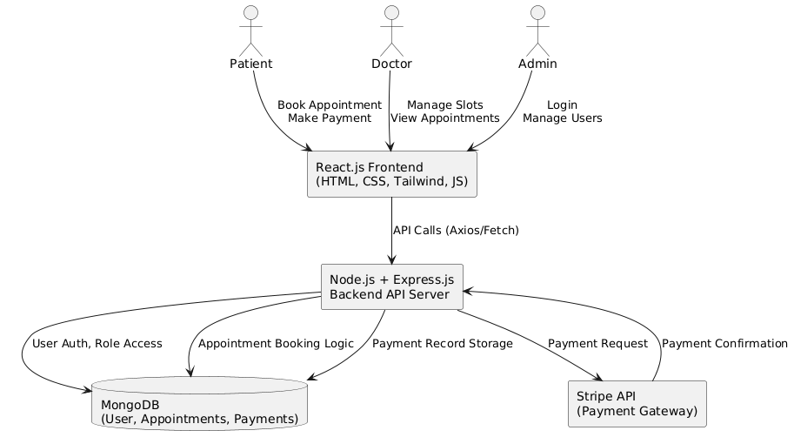

**Table-1 : Components & Technologies:**

|  |  |  |  |
| --- | --- | --- | --- |
| **S.No** | **Component** | **Description** | **Technology** |
| 1 | User Interface | How users interact with the application | HTML, CSS, tailwind@3, JavaScript, React.js |
| 2 | Application Logic-1 | Handles user authentication and role-based access | Node.js, Express.js |
| 3 | Application Logic-2 | Manages appointment booking, slot availability | Node.js, Express.js |
| 4 | Application Logic-3 | Integrates payment processing and confirmation | Node.js, Express.js |
| 5 | Database | Stores user data, appointment records, and payment info | MongoDB, NoSQL, Mongoose |
| 6 | External API-1 | Payment Gateway integration for appointment payments | Stripe API |

**Table-2: Application Characteristics:**

|  |  |  |  |
| --- | --- | --- | --- |
| S.No | Characteristics | Description | Technology |
| 1 | Open-Source Frameworks | List of open-source tools used for development of UI, backend, and state management. | React.js, Node.js, Express.js, Tailwind CSS, Mongoose |
| 2 | Security Implementations | JWT-based authentication, password hashing, secure API communication, and protection from common OWASP threats. | JWT, Bcrypt, HTTPS, CORS, Helmet, Express-rate-limit |
| 3 | Scalable Architecture | Modular architecture with clear separation of concerns (Frontend, Backend, Database). Easy to scale using container-based deployment or microservices. | MERN Stack, Docker (optional), RESTful APIs |
| 4 | Availability | Can be deployed on distributed cloud infrastructure, supports scaling with load balancers and concurrent sessions. | Render, Vercel, Load Balancers, Cloud Deployment |
| 5 | Performance | Optimized API routes, caching data for repeated queries, CDN for static assets, and minimal CSS with Tailwind for fast load times. | MongoDB Indexing, CDN (e.g., Cloudflare), Tailwind CSS, React Performance Tools |